**QUESTIONS**

**Ques-1:** Differentiate between EBS, EFS and S3 storage of AWS?

**Ans: EBS (Elastic Block Store)** is a block storage service that provides persistent storage volumes for use with Amazon EC2 instances. It is designed for frequently accessed data and supports both HDD and SSD storage.

**EFS (Elastic File System**) is a managed, scalable network file system for use with EC2 instances. It provides shared access to files across multiple instances and is designed for workloads that require high levels of throughput and parallel access.

**S3 (Simple Storage Service)** is an object storage service that provides scalable and durable storage for data and files. It can be used to store and retrieve any amount of data from anywhere on the web, and is often used as a central repository for files and data used by applications or websites.

In summary, EBS is block storage for use with EC2 instances, EFS is network file storage for use with EC2 instances, and S3 is object storage for storing and retrieving data from anywhere on the web.

**Ques-2:** Write the uses cases where EBS (block storage) will be more useful than others.

**Ans:** EBS (Elastic Block Store) is generally more useful than other storage options in the following use cases:

1. Databases: EBS is often used for storing database files due to its low latency and high input/output operations per second (IOPS) performance. This makes it ideal for database workloads that require fast, consistent performance.
2. High-performance computing: EBS is suitable for workloads that require high levels of performance and throughput, such as high-performance computing (HPC) and scientific computing.
3. Critical business applications: EBS is well-suited for storing critical business applications that require high availability and durability, as EBS volumes can be replicated across availability zones.
4. Boot volumes: EBS is often used to store boot volumes for EC2 instances, providing a persistent storage option that can be used across multiple instances.
5. File systems: EBS can be used to create file systems that can be shared across multiple EC2 instances, making it a good choice for workloads that require shared access to file systems.

In summary, EBS is useful for workloads that require high performance, low latency, durability, and availability, such as databases, high-performance computing, critical business applications, boot volumes, and file systems.

**Experiment 5: Attaching an EBS (external) to EC2 instance**

**(WINDOWS)**

**Step–1:** Click on create volume and create a new storage volume.

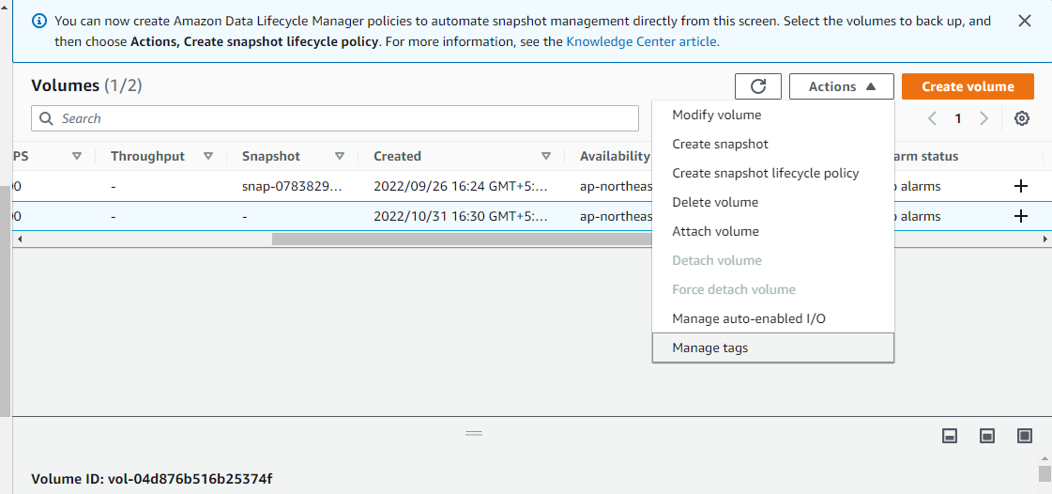

**Step-2:** Now click on Actions and click on attach volume. Fill in the instance details in which you want to attach EBS external storage.

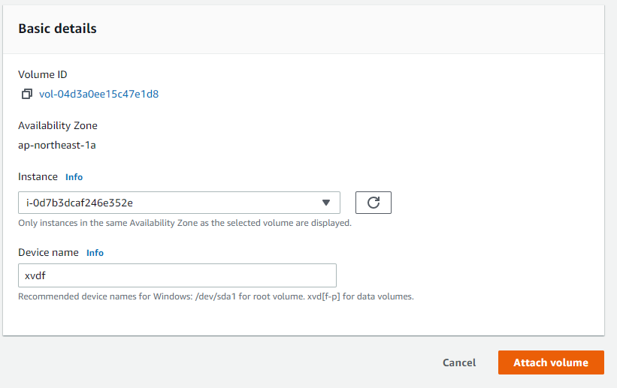

**Step-3:** Now click on the instance on which you have added the volume and check if the storage is attached or not.

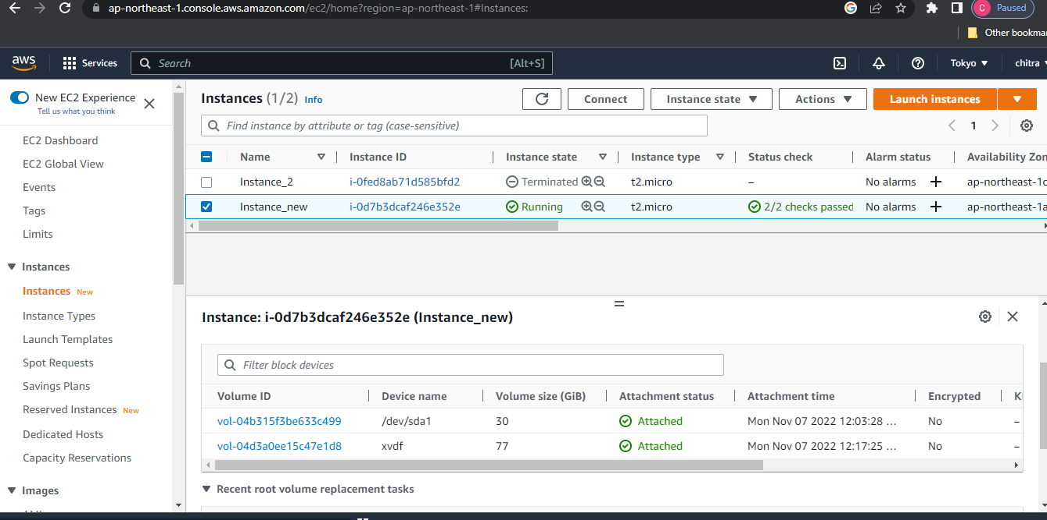

**Step-4:** Now connect to the EC2 machine using the public IP address of the instance on the remote desktop connection.

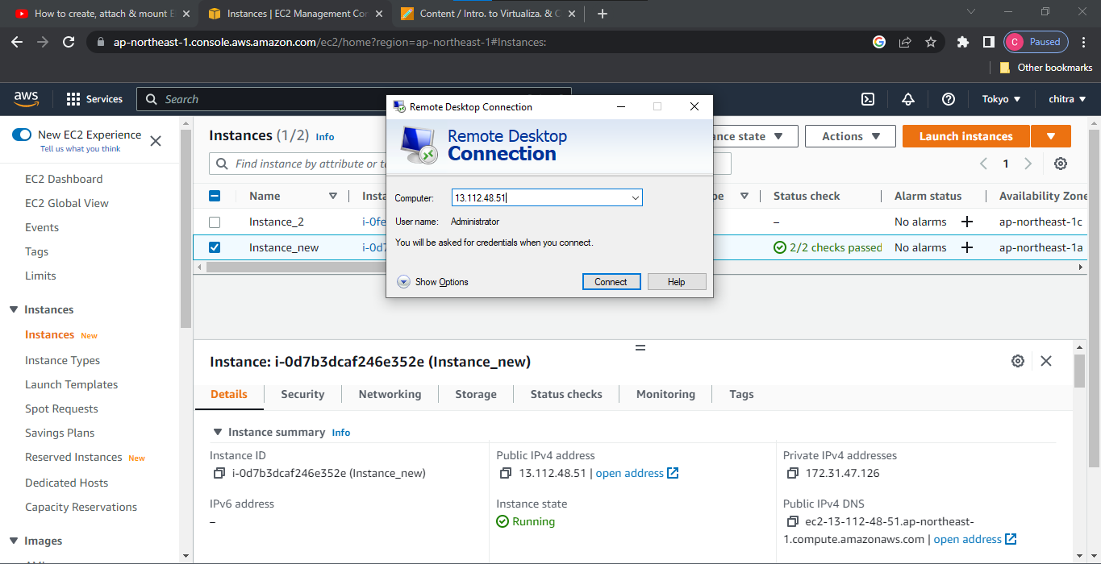

**Step-5:** Fill in the login credentials and click on ‘OK’.

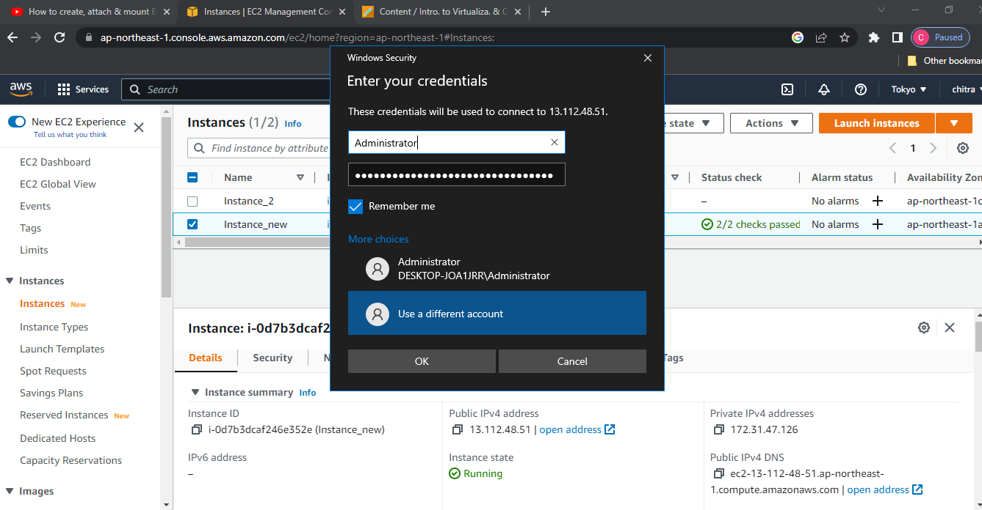

**Step-6:** Now open the disk management console on the EC2 machine.

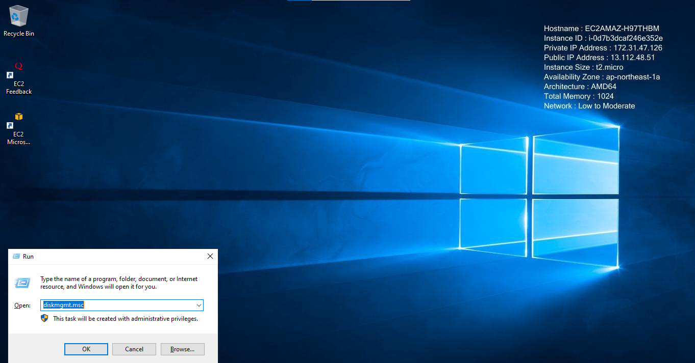

**Step-7:**Click on the Disk 1 and set it online and then initialize the disk. The external EBS volume is attached successfully.

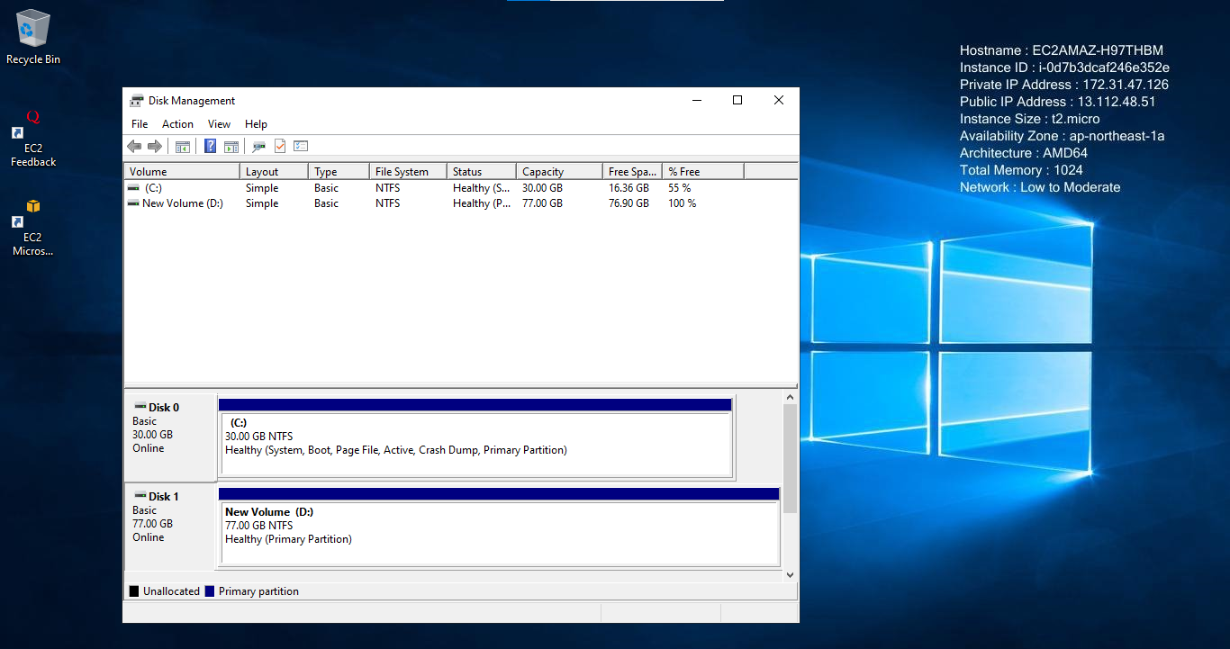

**Experiment 5: Attaching an EBS (external) to EC2 instance**

**(LINUX)**

**Step-1:** Creating a new volume and attaching it to the required Linux instance.

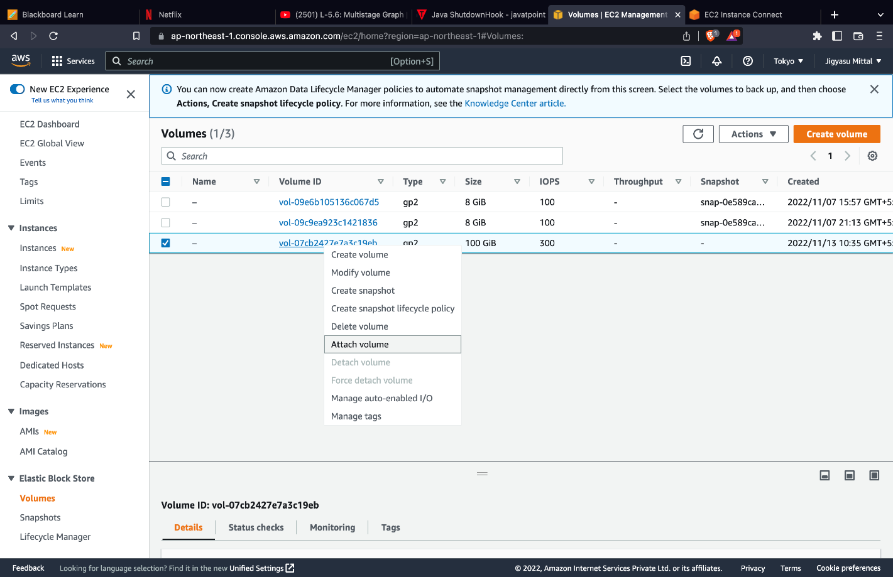

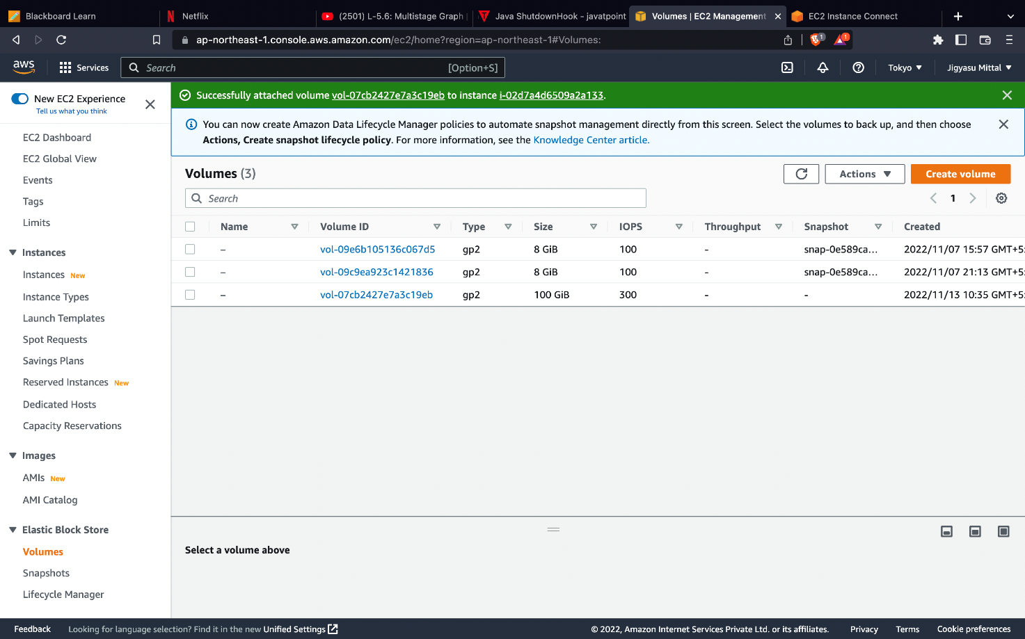

**Step-2**:Using “lsblk” command to see available disks and their mount points:

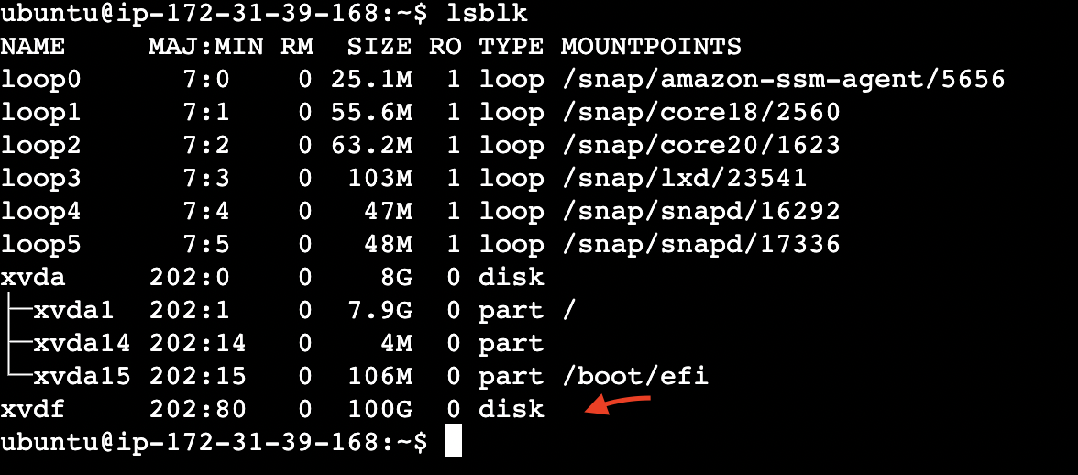

**Step-3:**The disk we attached is present at ‘/dev/xvdf’ and has not been mounted into the system since the mount point is empty.

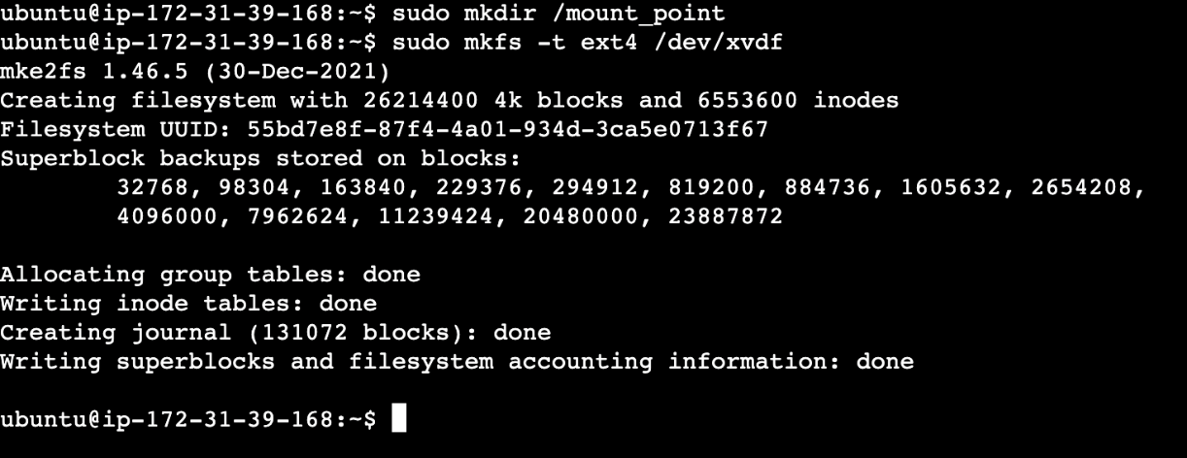

**Step-4:**Creating a directory using “mkdir” command where we will mount the disk and formatting the drive to ext4 file system using ‘mkfs’ command:

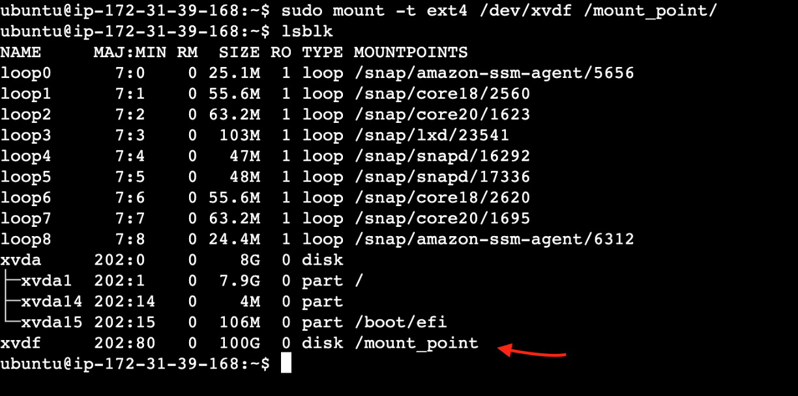

**Step-5:**Mounting the formatted disk using ‘mount’ command at “/mount_point/” :

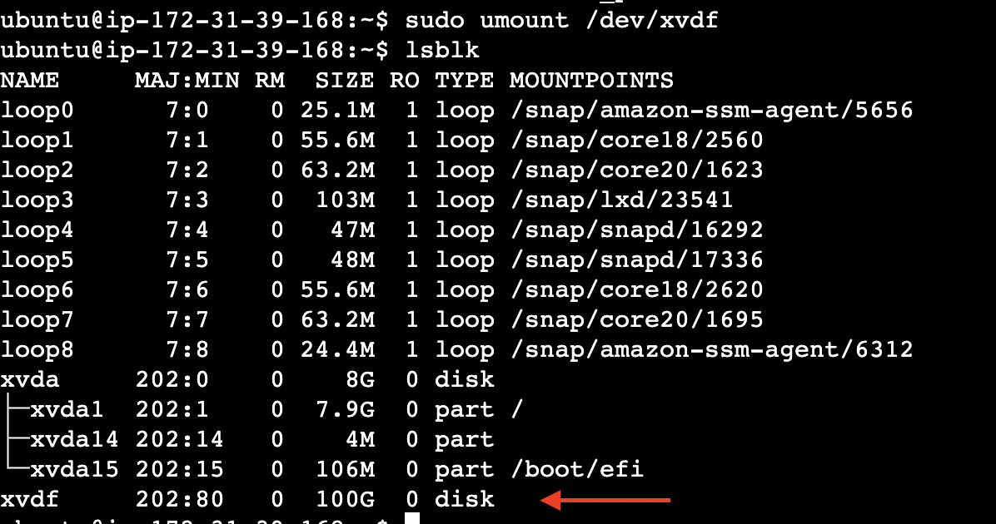

**Step-6:**Unmounting the disk using ‘umount’ command